### PROJECT BACKGROUND

Sound Transit is building 13 new light rail stations with service to West Seattle in 2030 and Ballard in 2035. The new light rail lines and transit tunnel under Downtown, South Lake Union and Seattle Center/Uptown is the largest transit investment in our city’s history. We are engaging with communities early and consistently throughout this project in partnership with Sound Transit.

### Q1 2020 SUMMARY

**18**

community  
 groups

**January 2020 - March 2020: Roadshow Part 1**

City and Sound Transit (ST) staff presented project basics to 18 existing community groups, boards and commissions, with a total of 329 participants.

* Racial Equity +Engagement (RE +E) created a list of more than 60 community groups, with a priority focus to reach out underrepresented people to ask that COS/ST representatives could brief attendees at existing meetings.
* Intended outcomes:
  + Start a conversation with community groups across the alignment, build knowledge among residents about the basics of WSBLE, outline the City’s role and partnership with Sound Transit and plant the seed for future conversations about how their neighborhoods can benefit from new light rail.
  + Provide highest value to communities by conducting all presentations with Sound Transit, eliminating the need for double meetings
* In March we cancelled all in-person events and have been pivoting the Roadshow to respond public health mandates for COVID-19. We hope to continue offering light rail presentations/conversations to the remaining groups when allowed or offer online engagement until COVID-19 restrictions are lifted.
* We are working on plans for summer WSBLE station workshops, in partnership with Sound Transit

### HOW IS OUR ENGAGEMENT WITH THE PUBLIC CENTERING PEOPLE OF COLOR AND LOW-INCOME PEOPLE?

* During Roadshow planning, staff intentionally identified groups that represent communities who are historically underserved, especially people of color, offering them the most flexibility in how and when we share information. Unfortunately, the coordination was cut short due to COVID-19 and we are now focusing on how to do outreach and gather input under those restrictions.
* We received feedback from underserved groups on ways we to modify our engagement approach to better serve the communities. However, during COVID pause we have begun conversations with Sound Transit on how best to implement these suggestions. These intentional strategies are discussed further below.
* Language access is a priority for this effort and the following materials are available in 8 languages: Dedicated web pages, guiding principles survey and intro video, project basics 2-pager and suggested social media posts for sharing info.

COVID-19 + RACISM   
The impacts of COVID-19 are revealing great and numerous inequities in our policies and practices, and the outcomes that flow from them. While these inequities are cast in stark relief, we want to use this opportunity to look more closely at how we operate and find ways to adapt our systems to be inclusive of all people. To do that, we must work in solidarity to eliminate racist practices and design new systems that produce the kinds of outcomes we say we want—outcomes that benefit people of color and other underrepresented groups instead of tearing them down. This is particularly relevant to light rail expansion because we have an opportunity to shift our practices and truly listen to and support people of color in our community by letting their voices shape how the project unfolds. We are committed to working in partnership with communities of color and low-income people and trying to engage with them on their terms.

### WORKPLAN DELIVERABLE STATUS

|  |  |
| --- | --- |
| DELIVERABLE | STATUS |
| Roadshow Materials – 2-pager and presentation | Completed |
| Roadshow presentations and calendaring/logistics – 17 groups attended before pause | Paused but ongoing |
| Roadshow Re-imagined with an emphasis on online engagement   * Guiding Principles intro video – (translated in top 7 languages) * Guiding Principles survey – using Survey Monkey and in 8 languages | Ongoing  Ongoing  Completed and ready to release to the public |
| Quarterly report-out | Completed |

### WHAT WE’VE BEEN ASKING + WHAT WE’VE HEARD Throughout the Roadshow, staff have been asking questions to community to guage their individual and neighbor priorities for light rail expansion. Those thoughts are summarized and posted on the web as [Quarter One Meeting Summaries [link forthcoming]. Commonly heard themes are summarized here, although they do not represent the views of all community members and are also not necessarily the views of the City of Seattle.

**Equity: Provide access to transit regardless of language proficiency, physical ability, age, income, or other status**

Highest ranking objective   
among survey respondents

Q: How can light rail be a positive change in your neighborhood or community?

* Build more affordable housing and provide opportunities for small businesses or social services near stations.
* Involve youth in the whole process.
* Support and grow small businesses.
* Provide easy transportation and connections between modes like walking, bus, bike, etc..

Q: What do you need in your neighborhood and around the station to make the most of light rail?

* Good connections for seniors and any people with disabilities to get to and from stations.
* Safe spaces to get to and from stations.
* A feeling of safety within the station for all people, especially LGBTQ folks and women.
* Welcoming entrances and other spaces.
* Respect for and preservation of the existing businesses and other cultural activities during all phases of the project.
* Good lighting.
* Public restrooms that are safe and accessible.

#### GUIDING PRINCIPLES SURVEY

City staff created a set of guiding principles based on previous community conversations, including ST’s winter workshops and other engagement efforts. The guiding principles are high level and meant to help City elected officials and staff focus their efforts in areas that reflect community values. The survey offers an opportunity to rate guiding principles according to importance. Overall, the guiding principle “Equity” received the highest level of prioritization by survey respondents. [Survey results to date are summarized here.](https://seattle.surveymonkey.com/results/SM-WKSBDLNX7/) After survey results are collected, City staff will make adjustments to the guiding principles to more accurately reflect what community members support.

**Dates:** February 4 – March 5, 2020

**How:** Paper surveys handed out at meetings and taken back by City staff at 18 events. 29 surveys collected.

### LOOK AHEAD TO Q2

TOP TIER LANGUAGES*

* Chinese (Simplified)
* Chinese (Traditional)
* Korean
* Somali
* Spanish
* Tagalog
* Vietnamese

*This list is informed by data from 2010 US Census and the 20xx American Community Survey

As the City restarts the community conversation around light rail expansion in May, we hope to:

* launch an expanded website and online survey promoted with a new social media video,
* solicit more community responses even as we continue social distancing.

The mentioned above are available in eight languages and have been vetted with trusted advocates; the [Community Liaisons](https://www.seattle.gov/neighborhoods/community-liaisons) (CLs). CL’s are working closely with City staff to ensure that our strategies and materials are effective for underserved communities. We will continue to work with community to guage when in-person presentations are welcome and appropriate after COVID restrictions are eased. The goal is to help communities participate in the Summer and Fall 2020 community workshops and to empower them with knowledge so they can provide comments to the Sound Transit Draft Environmental Impact Statement in early 2021.

#### CHALLENGES IN Q1

|  |  |
| --- | --- |
| **Challenge** | **Opportunity to Course Correct** |
| Engaging underrepresented communities and organizations in light of COVID-19 restrictions | During engagement pause, City staff are designing new strategies for engagement, including connecting with community-based organizations, community liaisons, and social media |

### MATERIALS

#### WEST SEATTLE AND BALLARD LIGHT RAIL EXPANSION 2-PAGER

Basic information about the project, the City’s objectives, information about how to stay connected with updates and who members of the public can contact if they have questions.

#### GUIDING PRINCIPLES SURVEY This survey is intended to get people thinking about how they want light rail route and stations to benefit their neighborhoods. The survey asks them to prioritize objectives that we will provided to City Sound Transit Board members. It will also be shared with City staff involved in decision making for all facets of the project.

|  |  |  |  |  |  |
| --- | --- | --- | --- | --- | --- |
| WSBLE 2-pager Links | | | Guiding Principles Survey Links | | |
| [English](http://www.seattle.gov/Documents/Departments/Neighborhoods/Planning/LightRailExpansion.pdf) | [Spanish](http://www.seattle.gov/Documents/Departments/Neighborhoods/Shared/Light%20Rail/LRE_OnePager_Span.pdf) | [Vietnamese](http://www.seattle.gov/Documents/Departments/Neighborhoods/Shared/Light%20Rail/LRE_OnePager_Viet.pdf) | [English](https://seattle.surveymonkey.com/r/LightRailEnglish) | [Spanish](https://seattle.surveymonkey.com/r/LightRailSpanish) | [Vietnamese](https://seattle.surveymonkey.com/r/LightRailVietnamese) |
| [Traditional Chinese](http://www.seattle.gov/Documents/Departments/Neighborhoods/Shared/Light%20Rail/LRE_OnePager_CNTrad.pdf) | [Korean](http://www.seattle.gov/Documents/Departments/Neighborhoods/Shared/Light%20Rail/LRE_OnePager_Kor.pdf) | [Somali](http://www.seattle.gov/Documents/Departments/Neighborhoods/Shared/Light%20Rail/LRE_OnePager_Somali.pdf) | [Traditional Chinese](https://seattle.surveymonkey.com/r/LightRailTraditionalChinese) | [Korean](https://seattle.surveymonkey.com/r/LightRailKorean) | [Somali](https://seattle.surveymonkey.com/r/LightRailSomali) |
| [Simplified Chinese](http://www.seattle.gov/Documents/Departments/Neighborhoods/Shared/Light%20Rail/LRE_OnePager_CNSim.pdf) | [Tagalog](http://www.seattle.gov/Documents/Departments/Neighborhoods/Shared/Light%20Rail/LRE_OnePager_Tagalog.pdf) |  | [Simplified Chinese](https://seattle.surveymonkey.com/r/LightRailSimChinese) | [Tagalog](https://seattle.surveymonkey.com/r/LightRailTagalog) |  |

#### WEBSITE

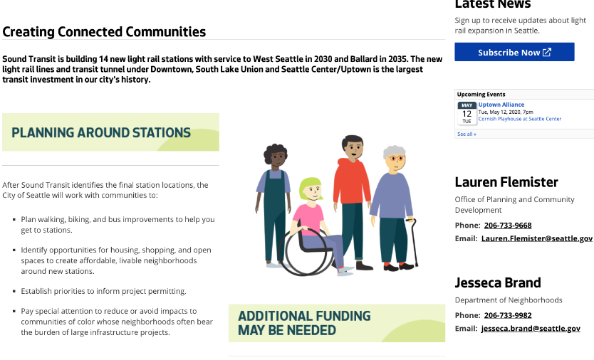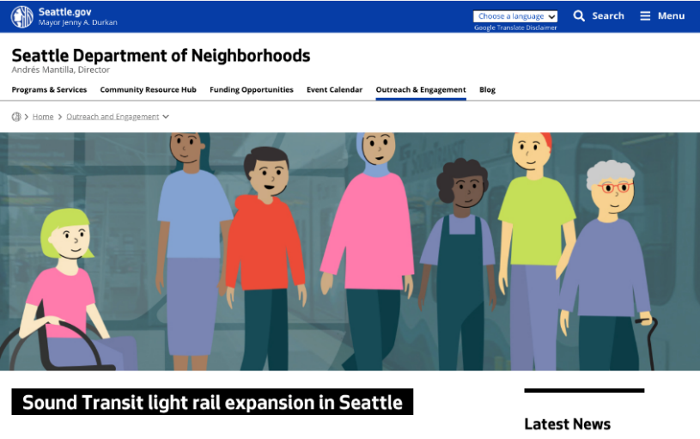

#### [Seattle.gov/lightrail](http://www.seattle.gov/neighborhoods/outreach-and-engagement/lightrail) provides basic WSBLE project details in English as well as pages in all Top Tier languages. Visitors can sign up for the e-newsletter, contact staff and see upcoming events. ACCESSIBILITY REPORT CARD

Our goal is to ensure that the materials we create and events we host are welcoming and accessible to all people. For example, the documents on our website should work well for screen readers and people using other assistive technologies.

The [Revised Section 508 standard](https://www.section508.gov/manage/program-roadmap), which provides guidance for creating accessible documents and other tools, includes a checklist of criteria. We chose criteria from the standard that are most relevant to the types of materials we are currently creating and are using them to evaluate the materials we share. [The Accessibility Scorecard for Q1 2020 on our website.](http://www.seattle.gov/Documents/Departments/Neighborhoods/Shared/Light%20Rail/AccessibilityScorecardQ12020.pdf) This quarter we got an 85% accessibility score. We’re shooting for 100%.

### RACIAL EQUITY + ENGAGEMENT WORK GROUP

The Racial Equity + Engagement (RE+E) Workgroup is led by Jesseca Brand in the Department of Neighborhoods and is comprised of multiple city departments who are coordinating with Sound Transit to conduct community engagement with the public. The goal of this workgroup is to ensure that racial equity, social justice and community engagement are integral to City and Sound Transit decision-making throughout the project and that community voices are reflected in final outcomes and decisions.